Link:

<http://supersstalker.s3-website-us-east-1.amazonaws.com>

Currently just a functional shell.

Front Page

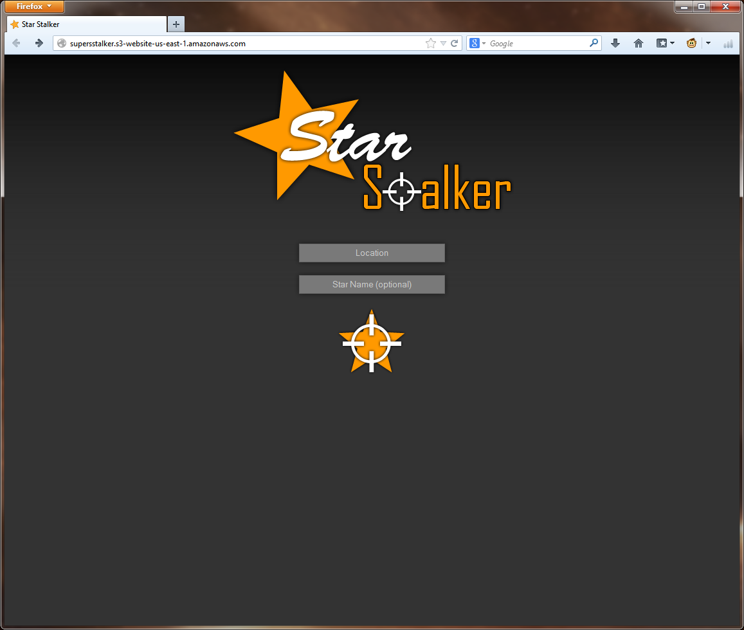

Location will be auto filled in or you can type it in and enter a star name if desired, then you click the button.

When you click the button it loads this page with the data and information we found on the left and the map marked with data. We also have the ability to search again at the top.

Search Page

